*Florida International University*

*School of Computing and Information Sciences*

Software Engineering Focus

Final Deliverable

Project Title: Learning with Virtual Reality

**Team Members: Edvin Li, Deon Davis**

**Product Owner(s)**: Shahin Vassigh

**Mentor(s)**: Albert Elias

**Instructor**: Masoud Sadjadi

The MIT License (MIT)

Copyright (c) *2016 Florida International University*

Permission is hereby granted, free of charge, to any person obtaining a copy of this software and associated documentation files (the "Software"), to deal in the Software without restriction, including without limitation the rights to use, copy, modify, merge, publish, distribute, sublicense, and/or sell copies of the Software, and to permit persons to whom the Software is furnished to do so, subject to the following conditions:

The above copyright notice and this permission notice shall be included in all copies or substantial portions of the Software.

THE SOFTWARE IS PROVIDED "AS IS", WITHOUT WARRANTY OF ANY KIND, EXPRESS OR IMPLIED, INCLUDING BUT NOT LIMITED TO THE WARRANTIES OF MERCHANTABILITY, FITNESS FOR A PARTICULAR PURPOSE AND NONINFRINGEMENT. IN NO EVENT SHALL THE AUTHORS OR COPYRIGHT HOLDERS BE LIABLE FOR ANY CLAIM, DAMAGES OR OTHER LIABILITY, WHETHER IN AN ACTION OF CONTRACT, TORT OR OTHERWISE, ARISING FROM, OUT OF OR IN CONNECTION WITH THE SOFTWARE OR THE USE OR OTHER DEALINGS IN THE SOFTWARE.

***Abstract***

*This document presents the information necessary to gain a good understanding of how the Learning with Virtual Reality project was managed. The project aims to improve the learning process of students of the School of Architecture. The first steps to accomplish this were to identify the problem to be solved and the requirements of the system. Through scrum development, the application was developed in 5 sprints of 2 weeks each. A new set of features and bug fixes were implemented to allow for Android and iOS deployment of the SKOPE-VR application. These changes were made with the intention of improving accessibility and user experience of the application for architecture students.*

**Table of Contents**

**Introduction** …………………………………………………………………………………………………………………………….. 5

Current System ……….…………………………………………………………………………………………………………... 5

Purpose of New System …………………………………………………..…………………………………………………... 5

**User Stories**

Implemented User Stories ………………………………………….………………………………………………………..6

Pending User Stories …………………………………………………………………...………………………………..……. 7

**Project Plan**

Hardware and Software Resources ……………………………………………………...……………………….…...8

Sprints Plan ……………………………………………………………..………………………………………………………. 10

*Sprint 1*  …………………………………………………………………………………………………………………………... 10

*Sprint 2*  …………………………………………………………………………………………………………………………... 12

*Sprint 3*  …………………………………………………………………………………………………………………………... 14

*Sprint 4*  …………………………………………………………………………………………………………………………... 16

*Sprint 5*  …………………………………………………………………………………………………………………………... 21

**System Design**

Architectural Patterns ………………………………………………………………………………………………….. 24

System and Subsystem Decomposition …………………………………………………………………………….… 25

Deployment Diagram …………………………………………………………………………………………………….…... 27

Design Patterns ………………………………………………………………………………………………………….….... 27

**System Validation**  …………………………………………………………………………………………………………………….29

**Glossary**  ………………………………………………………………………………………………………………………………….43

**Appendix**  ………………………………………………………………………………………………………………………………….44

Appendix A - UML Diagrams ………………………………………………………………………………………………. 44

*Static UML Diagrams*  ……………………………………………………………………………………………………….44

*Dynamic UML Diagrams*  …………………………………………………………………………………………………..52

Appendix B - User Interface Design …………………………………………………………………………….…... 62

Appendix C - Sprint Review Reports …………………………………………………………………………...…… 68

Appendix D - User Manuals, Installation/Maintenance Document, Shortcomings/Wishlist Document and other documents …………………………………………………………………….…………… 72

**References** ……………………………………………………………………………………………………………………...………...72

# Introduction

The Learning with Virtual Reality project was created with the hope of making learning more interactive and accessible through the use of technology. The application is closely related to the Learning with Virtual Reality project and combines Building Information Modeling (BIM), Virtual Reality (VR), visual simulations, and interactive lessons to support interdisciplinary learning for building sciences.

The new functionalities that were added to the project were implemented to achieve mobile compatibility of the application. The most important outcome of this project was to create and upload to the cloud a user compliance SKOPE-VR application for mobile phones to make it accessible for everyone.

## 

## Current System

The current application displays a 3D environment of the SIPA building and area surrounding it. The application is well refined and allows for interaction with a variety of icons and building structures. Users can walk around and click on icons to view building component information, diagrams, and videos. Some building components will display some information when you hover over it. The application is configured for deployment on PC, Mac and Linux Standalone.

## Purpose of New System

The purpose of the new system is to make the SKOPE-VR application compatible with mobile devices. Support for mobile user interaction, a mobile-compatible video player, and a variety of bug fixes and quality of life changes were added to allow for deployment to iOS and Android.

# User Stories

The following section provides the detailed user stories that were implemented in this iteration of the Learning with Virtual Reality project. These user stories served as the basis for the implementation of the project’s features. This section also shows the user stories that are to be considered for future development.

## Implemented User Stories

**Sprint 1**

* #208 - Understanding Unity and the project.
* #209 - Understanding Unity and the project.

**Sprint 2**

* #210 - Build VR to iOS
* #211 - Build VR to Android

**Sprint 3**

* #214 Add Animations
* #215 Add Geometry

**Sprint 4**

* #217 Movement via Touch
* #219 Loading Screen
* #221 Mobile Video Player
* #224 Touch Input for iOS
* #225 Touch Input for Android
* #230 Icon Camera View

**Sprint 5**

* #222 Toggle VR view for users
* #229 Icon Interaction
* #230 Icon Camera View

## Pending User Stories

* #220 Bug fix hole in stairs
* #226 Add third person view

# Project Plan

This section describes the planning that went into the realization of this project. This project incorporated the agile development techniques and as such required the sprints to be planned. These sprint plannings are detailed in the section. This section also describes the components, both software and hardware, chosen for this project.

## Hardware and Software Resources

The following is a list of all hardware and software resources that were used in this project:

**Hardware Specifications used for Computer One:**

* **5 GB of Solid State Drive space**
* **8 GB of RAM**
* **Intel i-5 4670K O.C. 4.2 GHz Processor**
* **AMD 7970 GHz 3GB GDDR5 O.C. 1125 MHz Core Clock, 1650 MHz Memory Clock**

**Hardware Specifications used for Computer Two:**

* **5 GB of Hard Drive space**
* **8 GB of RAM**
* **3.2 GHz Processor**
* **Intel chipset GPU**

**Hardware Resources used for Mobile Device:**

* **Two Samsung Galaxy S7**
* **One iPhone 7**

**Software Resources Used:**

* Windows 10 Operating System
* Microsoft Visual Studio 2017
* Unity 3D Version 5.6.2
* Github
* Git Bash
* Android Studio
* iOS SDK
* Android SDK

## 

## 

## Sprints Plan

The main focus of the Learning with Virtual Reality project was to create a working demo for the use of presenting it to the product owner’s supporters. Fundamental features necessary for the use of the project was added as well as bug fixes related to the deployment onto the mobile platform.

### Sprint 1

**User Story #208** - Understanding Unity and the Project.

* Description: As a user, I would like to learn how to use Unity and understand the project so that I can begin developing user stories and begin working on them.

**Acceptance Criteria:**

* An adequate understanding of how Unity works.
* Familiar with the current scope of the project and what could be done to improve it.

**Use Case:**

* Name: N/A
* Actor: N/A
* Preconditions: N/A
* Description <Flow of events>: N/A

**Modeling:**

* N/A

**User Story #209** - Understanding Unity and the Project.

* Description: As a user, I would like to learn how to use Unity and understand the project so that I can begin developing user stories and begin working on them.

**Acceptance Criteria:**

* An adequate understanding of how Unity works.
* Familiar with the current scope of the project and what could be done to improve it.

**Use Case:**

* Name: N/A
* Actor: N/A
* Preconditions: N/A
* Description <Flow of events>: N/A

**Modeling:**

* N/A

### Sprint 2

**User Story #210** - Build VR Project to iOS

* Description: As a User I would like to compile the project and publish to the iOS app store so that I can have a working demonstration of the application for use.

**Acceptance Criteria:**

* The project compiles and is pushed to the iOS App store.

**Use Case:**

* Name: N/A
* Actor: N/A
* Preconditions: N/A
* Description <Flow of events>: N/A

**Modeling:**

* NA

**User Story #211** - Build VR Project to Android

* Description: As a User I would like to compile the project and publish to the Android Play store so that I can have a working demonstration of the application for use.

**Acceptance Criteria:**

* The project compiles and is pushed to the Android Play store.

**Use Case:**

* Name: N/A
* Actor: N/A
* Preconditions: N/A
* Description <Flow of events>: N/A

**Modeling:**

* NA

### Sprint 3

**User Story #214** - Add Animations

* Description: As a User I would like to add more animations for a smoother transition for some features.

**Acceptance Criteria:**

* The animations on the environment is smoother.
* Movement animations transition better.

**Use Case:**

* Name:
* Actor: User
* Preconditions: User has installed Skope-VR application
* Description <Flow of events>:

1. User opens the Skope-VR Application

2. System loads and renders the scene

3. User views the shadow animations.

**Modeling:**

Refer to UML diagrams in Appendix A: Static UML Diagrams, Figure 1 and Dynamic UML diagrams, Figure 1a.

**User Story #215** - Add Geometry

* Description: As a User I would like to add more geometry so that I can have a better looking environment and building in the augmented reality.

**Acceptance Criteria:**

* The building looks smoother and has visibly less jaggedness.

**Use Case:**

* Name:
* Actor: User
* Preconditions: User has installed Skope-VR application
* Description <Flow of events>:

1. User opens the Skope-VR Application

2. System loads and renders the scene

3. User views the building

**Modeling:**

Refer to UML diagrams in Appendix A: Static UML Diagrams, Figure 2 and Dynamic UML diagrams, Figure 2a.

### Sprint 4

**User Story #217** - Movement Via Touch

* Description: As a User I would like to have touch input so that I control the movement of the player and explore the environment.

**Acceptance Criteria:**

* The application takes input from touch input and start the movement script when two fingers are pressed.
* Movement is continuous as long as two fingers are being held down.

**Use Case:**

* Name: Movement via Touch
* Actor: User
* Preconditions: The user has finished loading up the application.
* Description <Flow of events>:

1. User holds down two fingers on the screen.

2. The system starts the walking script and moves the player camera forward.

3. The user releases both fingers from the screen.

4. The user’s player camera stops moving.

**Modeling:**

Refer to UML diagrams in Appendix A: Static UML Diagrams, Figure 3 and Dynamic UML diagrams, Figure 3a.

**User Story #219** - Loading Screen

* Description: As a User I would like to have a loading screen so that I can know that application is loading and has not failed to start.

**Acceptance Criteria:**

* The loading screen has an animation to show that the application hasn’t crashed.

**Use Case:**

* Name: Loading Skope VR
* Actor: User
* Preconditions: User has Skope VR installed
* Description <Flow of events>:

1 User opens application

-System displays loading screen and begins loading main scene

1.1 User waits and views loading animation while scene loads

-System displays main scene once it is loaded

**Modeling:**

Refer to UML diagrams in Appendix A: Static UML Diagrams, Figure 4 and Dynamic UML diagrams, Figure 4a.

**User Story #221** - Mobile Video Player

* Description: As a User I would like to have a way to open videos in the application so that I can view them and learn more about the SIPA building

**Acceptance Criteria:**

* Videos in the application can be clicked and video will begin playing in fullscreen.
* User can pause, play, fast forward, and rewind video while it is playing.
* Once video is finished, user returns to their previous view.

**Use Case:**

* Name: Playing a Video
* Actor: User
* Preconditions: User has loaded app
* Description <Flow of events>:

1 User clicks on a video

-System displays video in fullscreen

1.1 User finishes video

-System sends player camera back to where it was before video

**Modeling:**

Refer to UML diagrams in Appendix A: Static UML Diagrams, Figure 5 and Dynamic UML diagrams, Figure 5a.

**User Story #224** - Touch Input for iOS

* Description: As a User I would like to have touch input so that I can interact with the application using the touch screen.

**Acceptance Criteria:**

* The application takes input from touch input and uses it as button presses in game.
* Can keep track of how many fingers are being used and perform different tasks based on amount of fingers.

**Use Case:**

* Name: Touch Input
* Actor: User
* Preconditions: The user has finished loading up the application.
* Description <Flow of events>:

1. User places one finger on the screen.

2. System displays amount of fingers being placed.

3. User hovers over icon and places finger on screen.

4. System processes the input and interact with icon.

**Modeling:**

Refer to UML diagrams in Appendix A: Static UML Diagrams, Figure 6 and Dynamic UML diagrams, Figure 6a.

**User Story #225** - Touch Input for Android

* Description: As a User I would like to have touch input so that I can interact with the application using the touch screen.

**Acceptance Criteria:**

* The application takes input from touch input and uses it as button presses in game.
* Can keep track of how many fingers are being used and perform different tasks based on amount of fingers.

**Use Case:**

* Name: Touch Input
* Actor: User
* Preconditions: The user has finished loading up the application.
* Description <Flow of events>:

1. User places one finger on the screen.

2. System displays amount of fingers being placed.

3. User hovers over icon and places finger on screen.

4. System processes the input and interact with icon.

**Modeling:**

Refer to UML diagrams in Appendix A: Static UML Diagrams, Figure 6 and Dynamic UML diagrams, Figure 6a.

### Sprint 5

**User Story #222** - Toggle VR View

* Description: As a User I would like to be able to toggle the cardboard view so that I can turn off VR view on mobile and enable for VR headsets.

**Acceptance Criteria:**

* The VR cardboard view is no longer visible.
* One image is present and no longer renders two separate ones.
* The option can be toggled on and off.

**Use Case:**

* Name: Toggle VR POV for mobile users
* Actor: User
* Preconditions: User has loaded the application.
* Description <Flow of events>:

1. User loads the application

2. The system displays with VR view.

3. The user toggles the VR view off.

4. The system renders the image without the VR lense view and has one image only.

**Modeling:**

Refer to UML diagrams in Appendix A: Static UML Diagrams, Figure 7 and Dynamic UML diagrams, Figure 7a.

**User Story #229** - Icon Interaction

* Description: As a User I would like to be able to tap on the icons to open them up and have the camera automatically move to view it so that I can view the panel of information it provides and open up movies.

**Acceptance Criteria:**

* Taps register in the application and will move open up the content the icon has.
* Taps are registered and opens up a movie if the icon provides a movie.
* Taps on the icon will move user to icon automatically.
* Taps on the icon after the initial one will move user back to previous position.

**Use Case:**

* Name:Icon Interaction
* Actor:User
* Preconditions:

The application has loaded up.

The user has the camera hovering over an icon

* Description <Flow of events>:

1. The user taps on the screen while hovering over an icon.

2. The System opens the icon’s information panel and move the user’s camera in front of it.

3. The user taps on the icon again.

4. The system closes the panel and moves user back to previous position.

Special Cases:

1. The user taps on the screen while hovering over an icon.

2.1 The System opens the icon’s movie player.

**Modeling:**

Refer to UML diagrams in Appendix A: Static UML Diagrams, Figure 8 and Dynamic UML diagrams, Figure 8a and 8b for the special case.

**User Story #230** - Icon Camera View

* Description: As a User I would like be able to see icons, even if they are behind building structures so that click them regardless of where I am in the environment.

**Acceptance Criteria:**

* Icons are viewable and clickable, even if they are behind other building structures

**Use Case:**

* Name: Viewing and clicking icons
* Actor: User
* Preconditions: User has loaded app
* Description <Flow of events>:

1 User moves to face building

-System shows icons in front of building

1.1 User clicks on icon

-System zooms camera in for interaction

**Modeling:**

Refer to UML diagrams in Appendix A: Static UML Diagrams, Figure 9 and Dynamic UML diagrams, Figure 9a.

# System Design

This section contains information on the design decisions that went into this project. The architecture patterns are outlined and explained. The entire system is shown in a package diagram and the subsystems are explained. Finally, the design patterns used in the project are discussed.

## Architectural Patterns

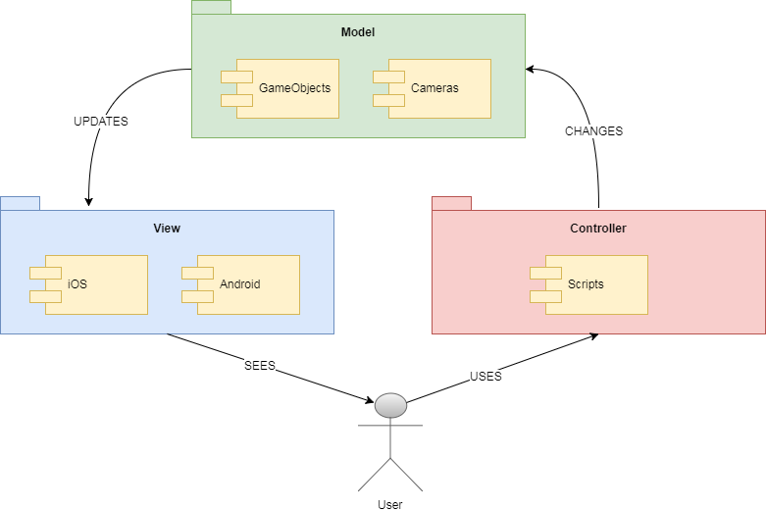

Our system can be viewed as a Model-View-Controller (MVC) architectural pattern. The model component of our system is composed of the scenes which include the various game objects and cameras. These objects are manipulated by the scripts in the controller component of the system. The scripts are constantly running, and detect input from the user make changes to the model. The view component is composed the frames that are rendered by the cameras in the model component and displayed on the user’s screen.

## System and Subsystem Decomposition

This section provides a brief introduction to each subsystem in the minimal class diagram.

* **VRState -** Interface that will establish the behavior of the other states.
* **mainStateVR -** The main state that the scene initially loads into.
* **MovieTexturePlayer -** The system where movie playing is done.
* **IconStateVR -** The state where a user views an icon.
* **Description -** The system where a describes the information from each icon.
* **FPCamScript -** The system where it keeps track of the first person camera.
* **StatePatternEnvironment -** A controller that keeps track of which state the user is in and manages transitions between states.
* **MajorComponentState -** A state controller that handles the script actions in regards to each state.
* **CameraState -** The camera system in relation to the FPCamScript.
* **mechanicalState -** The state that handles the rendering of the building, animations, and geometry.
* **DiagramState -** The state that handles the ability for users to view icons.
* **subComponentState -** The system that handles the secondary scripts for a state.
* **buildState -** The state inside the building.
* **mechanicalRoomState -** The state when playing a video.

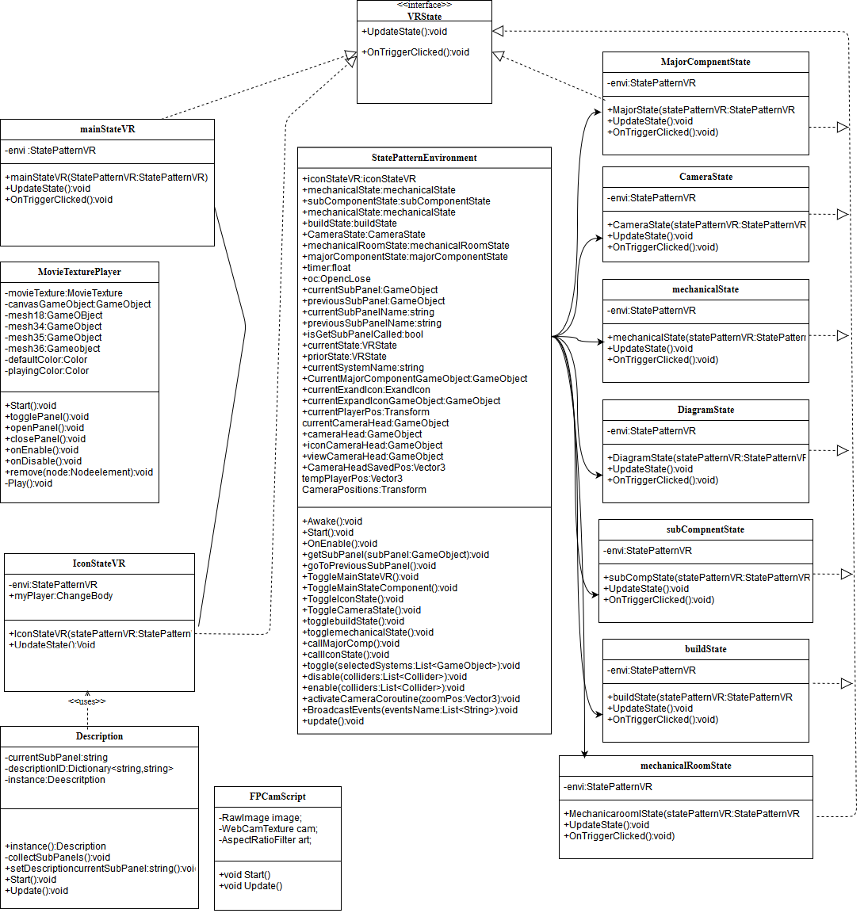*Minimal Class Diagram of the System.*

## Deployment Diagram

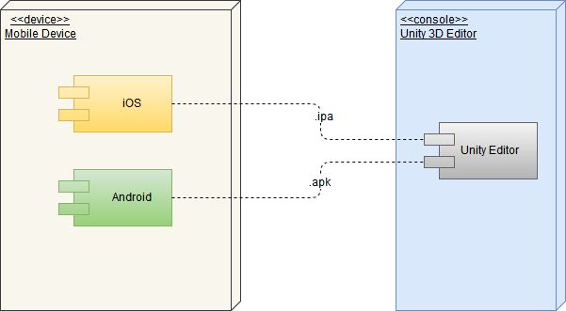

## Design Patterns

The Decorator Pattern is a type of structural pattern that was used in this project. The decorator pattern allows for an individual object’s behavior to be modified either statically or dynamically without affecting the behavior of other objects in the same class. In this application, every model is created as its own object, the camera is a separate object, as well as the various icons and interactions. To keep an organized environment, modifications were only attached to the object that needed the changes. To enable a behavior, a script would be attached to an object that allows it functionality.

This also follows the Single Responsibility Principle in that each object is its own class and has responsibility for only a single part of the functionality of the application. This allows us to focus on what needs to be done and easily modify existing code because each class or object should only have one reason to be modified. If our current need to change something fits that need, then the decision becomes easier.

# System Validation

Unit tests are essential to test functionality of each feature in the application. The test cases in this section are used to validate their respective user stories.

**User Story #217 Movement Via Touch**

|  |
| --- |
| **Test ID: LAR_Movement_Touch** |
| **Purpose:**  Move user forward if two fingers are being pressed. |
| **Pre-Condition:**  User has loaded the application and places two fingers on the screen. |
| **Expected Results:**  User and camera all move forward |
| **Actual Results:**  User and camera moved forward |
| **Status:**  Pass |

|  |
| --- |
| **Test ID: LAR_Movement_Touch_Stop** |
| **Purpose:**  User is not moving if there are not two fingers pressing the screen. |
| **Pre-Condition:**  User has loaded the application and is moving with two fingers pressing the screen.  User removes finger from screen. |
| **Expected Results:**  User and camera come to a stop. |
| **Actual Results:**  User and camera stopped. |
| **Status:**  Pass |

**User Story #219 - Loading Screen**

|  |
| --- |
| **Test ID: Loading_Screen_Test** |
| **Purpose:**  Tests whether loading screen displays correctly while main scene loads. |
| **Pre-Condition:**  User opens application. |
| **Expected Results:**  Loading screen appears on application open and displays animation until main scene is loaded. |
| **Actual Results:**  Loading screen appears on application open and displays animation until main scene is loaded. |
| **Status:**  Pass |

**User Story #221 - Mobile Video Player**

|  |
| --- |
| **Test ID: Video_Play** |
| **Purpose:**  Tests if videos are being displayed correctly. |
| **Pre-Condition:**  User opens application, and clicks a video. |
| **Expected Results:**  Video plays in fullscreen and returns player to same position when finished. |
| **Actual Results:**  Video plays in fullscreen and returns player to same position when finished. |
| **Status:**  Pass |

|  |
| --- |
| **Test ID: Video_Player_Test** |
| **Purpose:**  Tests if the features within the video player are working as expected. |
| **Pre-Condition:**  User opens application and clicks on a video. |
| **Expected Results:**  Video player has a working play/pause button, a fast forward button, and a rewind button. |
| **Actual Results:**  Video can pause/play, rewind, and fast forward. |
| **Status:**  Pass |

**User Story #224 - Touch Input for iOS**

|  |
| --- |
| **Test ID: LAR_Touch_Input_Icon** |
| **Purpose:**  Tapping on an Icon will register and switch to Icon State |
| **Pre-Condition:**  User has loaded the application and tapped on an icon. |
| **Expected Results:**  Icon state is loaded and icon interaction begins. |
| **Actual Results:**  Switched to icon state and icon panel loads. |
| **Status:**  Pass |

|  |
| --- |
| **Test ID: LAR_Touch_Input_Move** |
| **Purpose:**  Double finger input registers and activates movement scripts. |
| **Pre-Condition:**  User has loaded the application and places two fingers on screen. |
| **Expected Results:**  Movement script activates and moves user. |
| **Actual Results:**  User begins moving. |
| **Status:**  Pass |

|  |
| --- |
| **Test ID: LAR_Touch_Input_Count_3Finger** |
| **Purpose:**  Testing to see if system keeps track of the amount of fingers being placed on the screen. |
| **Pre-Condition:**  User has loaded the application and places three fingers on the screen. |
| **Expected Results:**  System logs out the number of touch inputs being registered as three. |
| **Actual Results:**  Three touch inputs are registered. |
| **Status:**  Pass |

**User Story #225 - Touch Input for Android**

|  |
| --- |
| **Test ID: LAR_Touch_Input_Icon** |
| **Purpose:**  Tapping on an Icon will register and switch to Icon State |
| **Pre-Condition:**  User has loaded the application and tapped on an icon. |
| **Expected Results:**  Icon state is loaded and icon interaction begins. |
| **Actual Results:**  Switched to icon state and icon panel loads. |
| **Status:**  Pass |

|  |
| --- |
| **Test ID: LAR_Touch_Input_Move** |
| **Purpose:**  Double finger input registers and activates movement scripts. |
| **Pre-Condition:**  User has loaded the application and places two fingers on screen. |
| **Expected Results:**  Movement script activates and moves user. |
| **Actual Results:**  User begins moving. |
| **Status:**  Pass |

|  |
| --- |
| **Test ID: LAR_Touch_Input_Count_3Finger** |
| **Purpose:**  Testing to see if system keeps track of the amount of fingers being placed on the screen. |
| **Pre-Condition:**  User has loaded the application and places three fingers on the screen. |
| **Expected Results:**  System logs out the number of touch inputs being registered as three. |
| **Actual Results:**  Three touch inputs are registered. |
| **Status:**  Pass |

**User Story #222 - Toggle VR view for users**

|  |
| --- |
| **Test ID: LAR_DisableVR** |
| **Purpose:**  Remove VR view to have more clarity in application viewing. |
| **Pre-Condition:**  User has loaded the application.  The VR view is enabled. |
| **Expected Results:**  Environment does not have VR cardboard view enabled and displays everything in one image. |
| **Actual Results:**  VR view is disabled and only shows one image. |
| **Status:**  Pass |

|  |
| --- |
| **Test ID: LAR_EnableVR** |
| **Purpose:**  Enable VR view to have more clarity in application viewing with VR headsets. |
| **Pre-Condition:**  User has loaded the application.  The VR view is disabled. |
| **Expected Results:**  Environment will have VR cardboard view enabled and displays everything in as stereoscope view. |
| **Actual Results:**  VR view is enabled and only shows two images. |
| **Status:**  Pass |

**User Story #229 - Icon Interaction**

|  |
| --- |
| Test ID: LAR_IconInteraction_Text |
| Purpose:  Test whether taps open up icon panels. |
| Pre-Condition:  User has loaded up the application.  User has the camera hovering over an icon.  User taps on the icon. |
| Expected Results:  The icon will open up a panel displaying information. |
| Actual Results:  The icon opens up text information about that panel |
| Status:  Pass |

|  |
| --- |
| Test ID: LAR_IconInteraction_Movie |
| Purpose:  Test whether taps open up icon panels. |
| Pre-Condition:  User has loaded up the application.  User has the camera hovering over an icon.  User taps on the icon. |
| Expected Results:  The icon will open up a panel displaying the movie player. |
| Actual Results:  The icon opens up movie player. |
| Status:  Pass |

|  |
| --- |
| Test ID: LAR_IconInteraction_NewCamera |
| Purpose:  Test whether the camera will move to the icon when the icon is pressed. |
| Pre-Condition:  User as pressed on the icon and the panel opened. |
| Expected Results:  The user’s camera will navigate itself to be in front of the icon’s panel. |
| Actual Results:  The camera moves to view the icon’s panel. |
| Status:  Pass |

**User Story #230 - Icon Camera View**

|  |
| --- |
| **Test ID: Icon_Viewable** |
| **Purpose:**  Tests if icons are being rendered correctly |
| **Pre-Condition:**  User loads application. |
| **Expected Results:**  Icon should be viewable and clickable through walls |
| **Actual Results:**  Icon can be seen and clicked through walls |
| **Status:**  Pass |

# Glossary

* **OS** - Operating System
* **VR** - Virtual Reality
* **User** - A person using the application on a mobile device.
* **SIPA** - School of International and Public Affairs. This is the building the application is modeled after.
* **Icon** - The location image present throughout the virtual environment.
* **iOS** - Apple iPhone operating system
* **Android** - Operating system for mobile devices such as the Samsung Galaxy S7.
* **Samsung Galaxy S7** - A phone from the Samsung brand. Runs on Android.
* **iPhone 7 -** A phone from the Apple brand. Runs on iOS.

# Appendix

## Appendix A - UML Diagrams

**Static UML Diagrams**

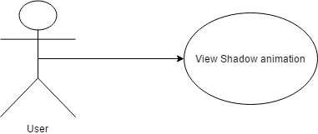

*Figure 1. UML Diagram for* ***Add Animations****, user story #214.*

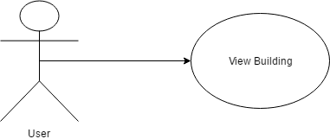

*Figure 2. UML Diagram for* ***Add Geometry****, user story #215.*



*Figure 3. UML Diagram for* ***Movement Via Touch****, user story #217*

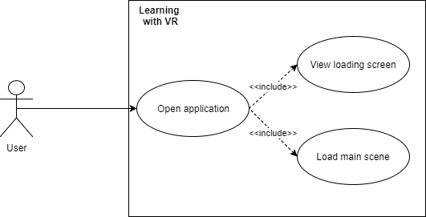

*Figure 4. UML Diagram for* ***Loading Screen****, user story #219.*

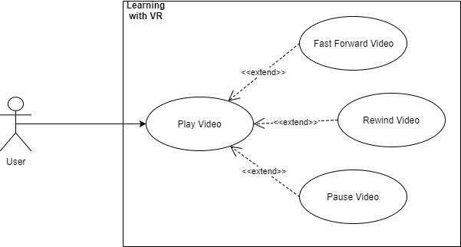

*Figure 5. UML Diagram for* ***Mobile Video Player****, user story #221.*



*Figure 6. UML Diagram for* ***Touch Input for iOS and Android****, user story #224.*



*Figure 7. UML Diagram for* ***Toggle VR View for Users****, user story #222.*



*Figure 8. UML Diagram for* ***Icon Interaction****, user story #229.*

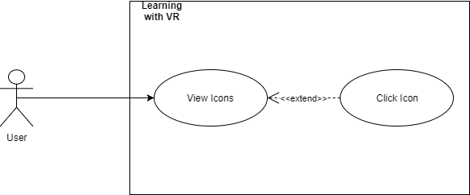

*Figure 9. UML Diagram for* ***Icon Camera View****, user story #230.*

**Dynamic UML Diagrams**

*Figure 1a. Dynamic UML Diagram for* ***Add Animations****, user story #214.*

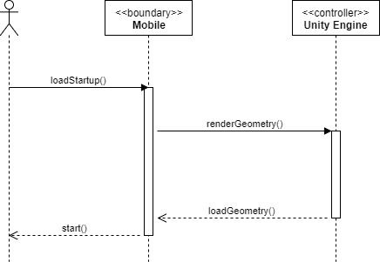

*Figure 2a. Dynamic UML Diagram for* ***Add Geometry****, user story #215.*

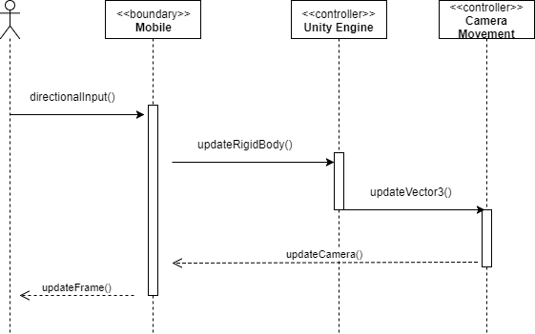

*Figure 3a. Dynamic UML Diagram for* ***Movement Via Touch****, user story #217.*

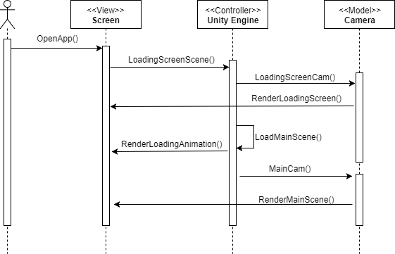

*Figure 4a. Dynamic UML Diagram for* ***Loading Screen****, user story #219.*

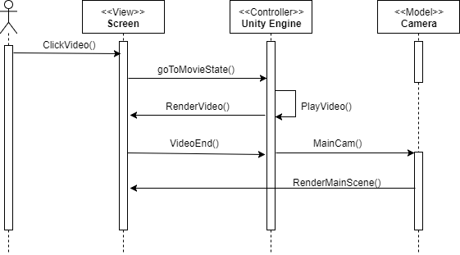

*Figure 5a. Dynamic UML Diagram for* ***Mobile Video Player****, user story #221.*



*Figure 6a. Dynamic UML Diagram for* ***Touch Input for iOS and Android****, user story #224 and #225.*

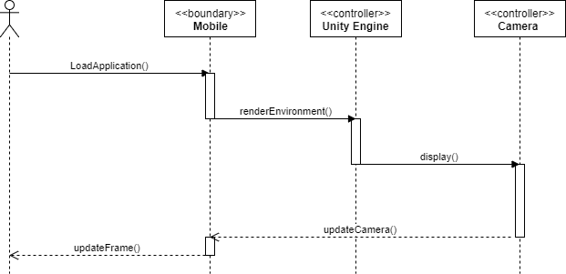

*Figure 7a. Dynamic UML Diagram for* ***Toggle VR view for Users,***  *user story #222.*



*Figure 8a. Dynamic UML Diagram for* ***Icon Interaction,***  *user story #229.*



*Figure 8b. Dynamic UML Diagram for* ***Icon Interaction,*** *special case, user story #229.*

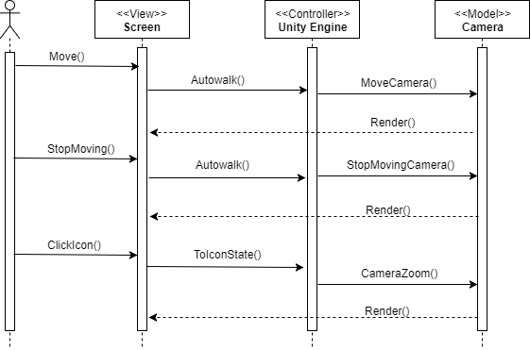

*Figure 9a. Dynamic UML Diagram for* ***Icon Camera View,***  *user story #230.*

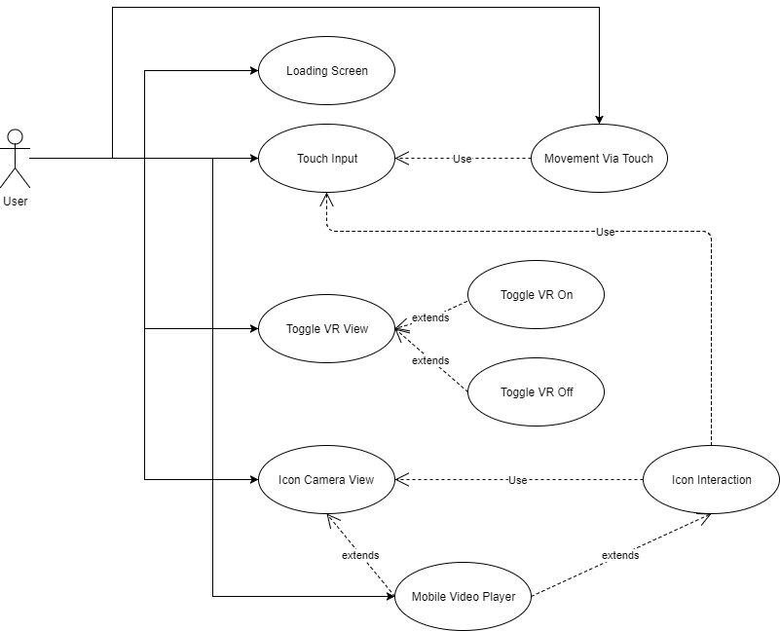*Figure 16.Use Case Diagram for Learning with Virtual Reality Summer 2017.*

## Appendix B - User Interface Design

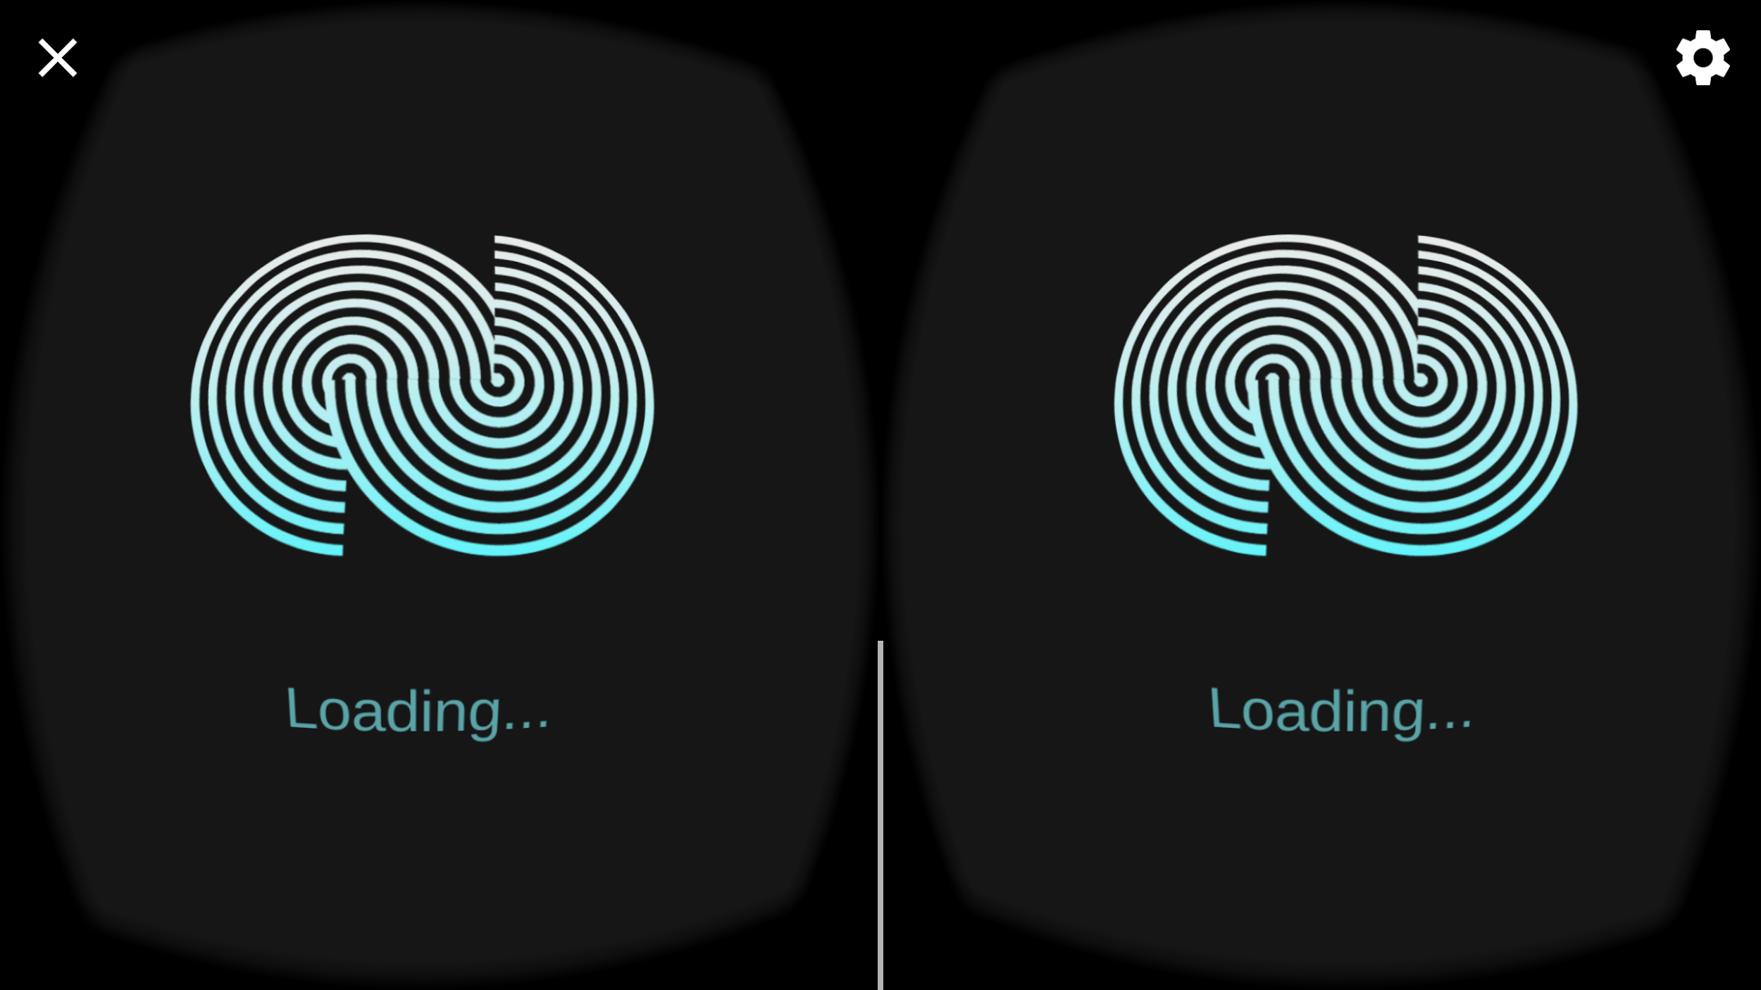

*Figure 10 Loading Screen*

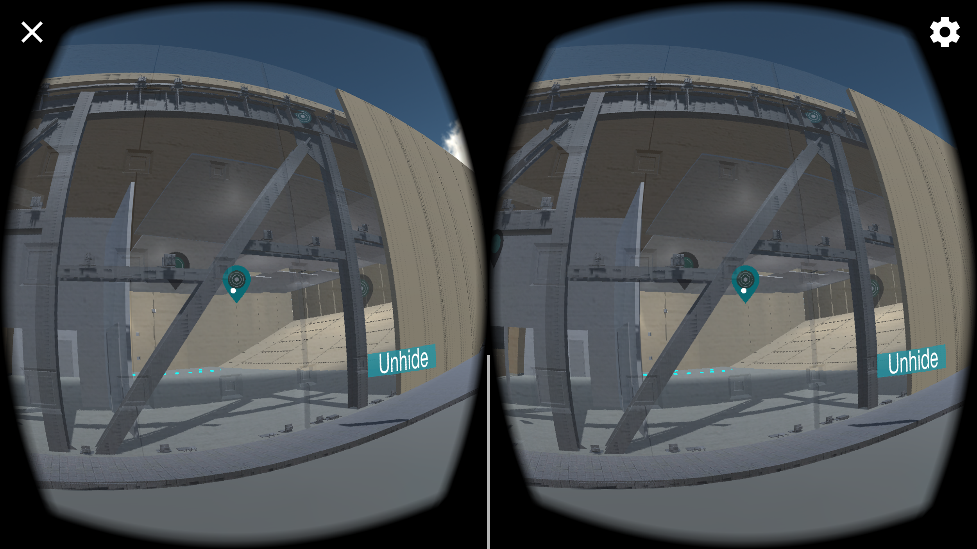

*Figure 11 Component Icon*

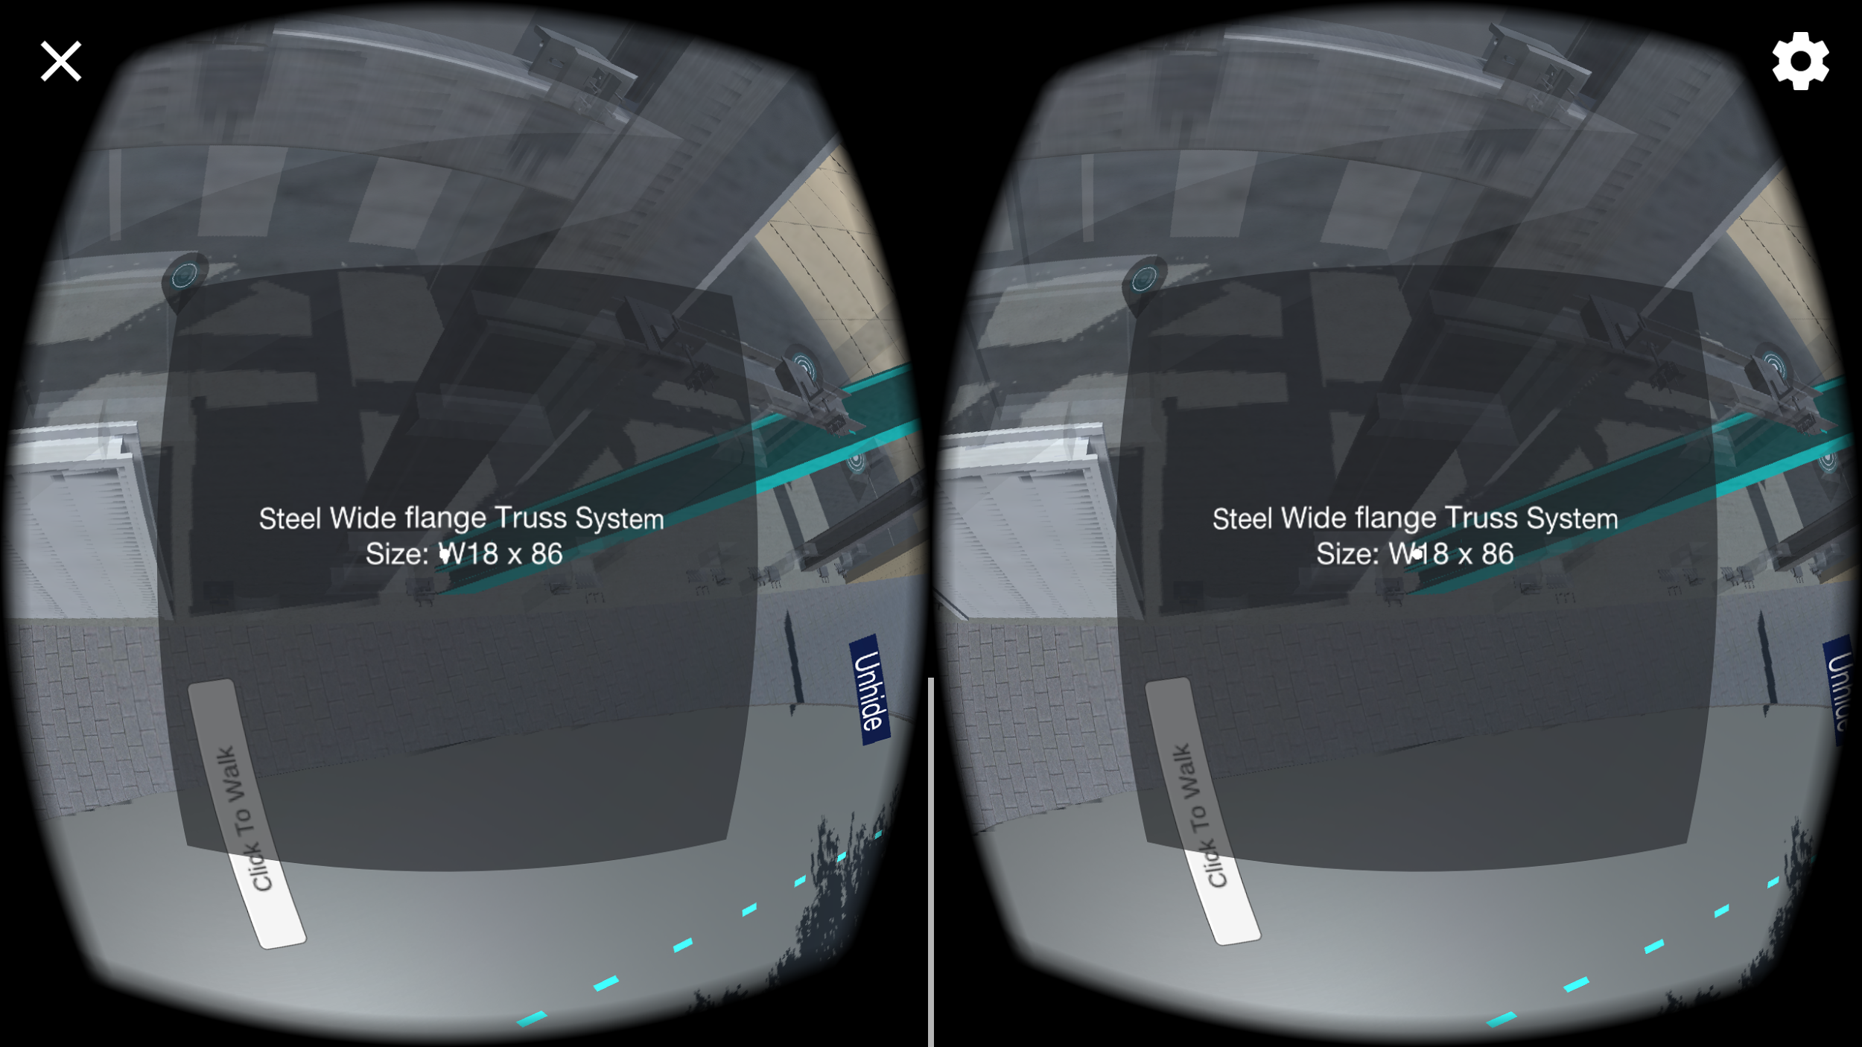

*Figure 12 Component Details*

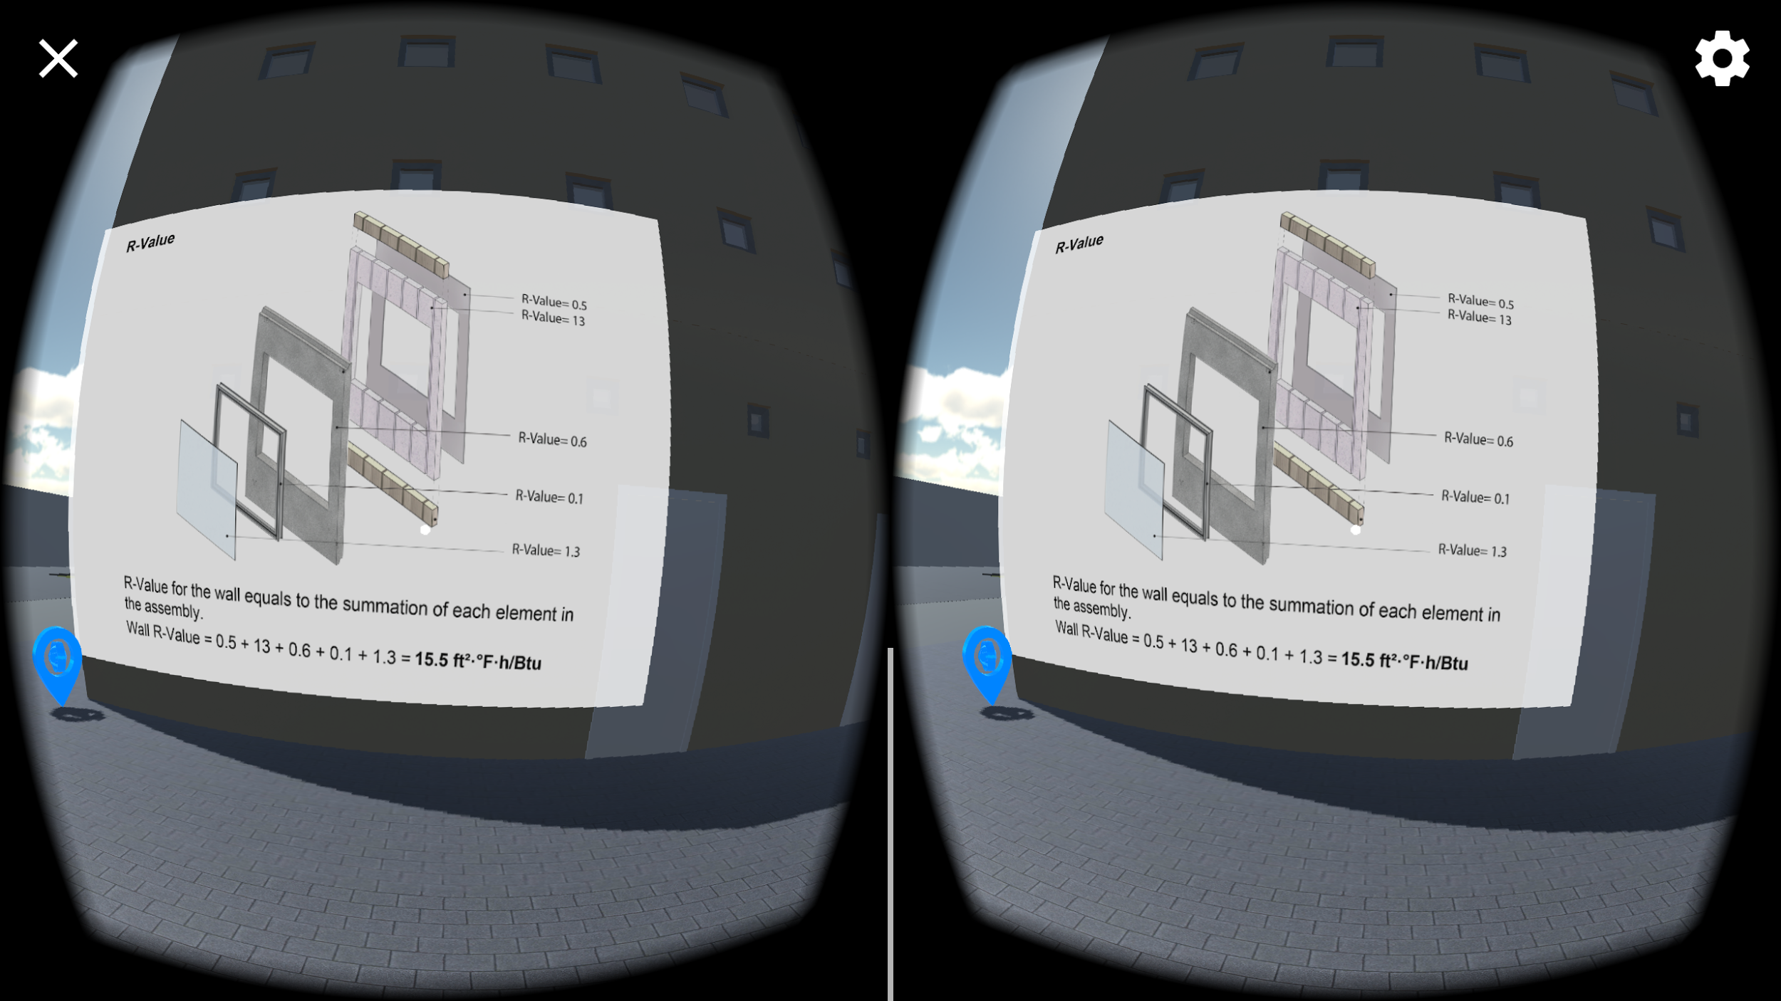

*Figure 13 Diagram Icon and Diagram*

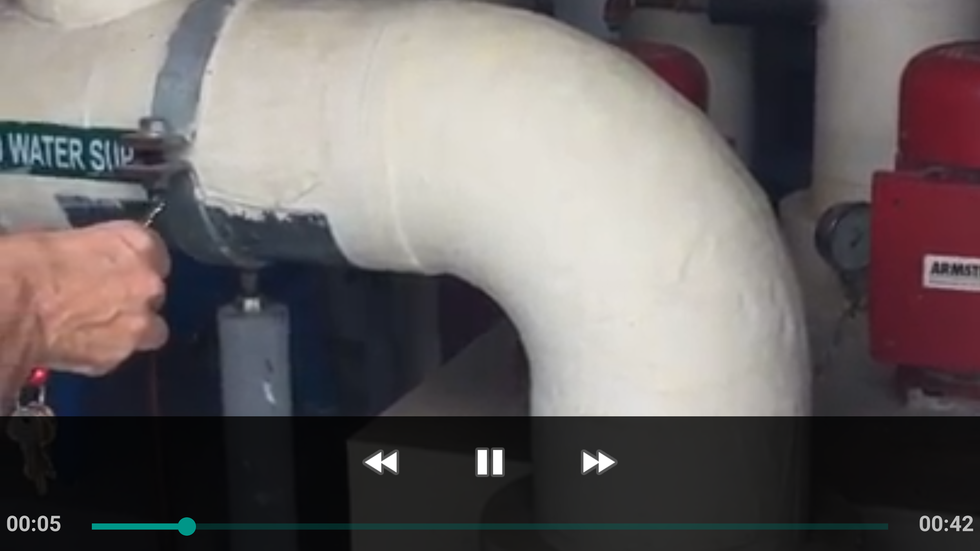

*Figure 14 Video*

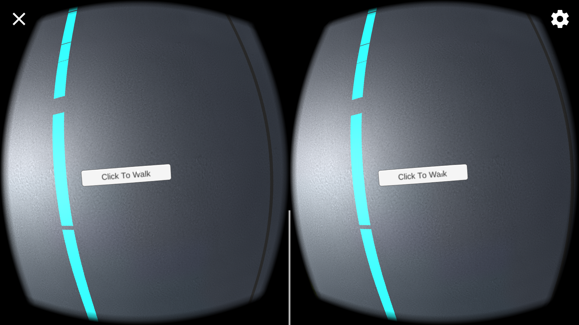

*Figure 15 Click to walk button*

## 

## 

## 

## 

## 

## Appendix C - Sprint Review Reports

**Sprint 1**

Attendees: Deon Davis, Edvin Li, Shahin Vassigh, Albert Elias

Start time: May 23, 2017 11:00 AM

End time: May 23, 2017 11:40 AM

After a show and tell presentation, the implementation of the following user stories were accepted by the product owners: All.

* User Story #208 Understanding Unity and Project
* User Story #209 Understanding Unity and Project

The following ones were rejected and moved back to the product backlog to be assigned to a future sprint at a future Spring Planning meeting.

* N\A. The product owner suggests we familiarize ourselves with Unity and the latest version of the project from their github first before we begin developing other use cases in the next sprint meeting.
* How this should be reflected on the user story definition in Mingle:
  + Should not be added to Mingle because no user stories are defined yet until the next sprint meeting.

**Sprint 2**

Attendees: Deon Davis, Edvin Li, Shahin Vassigh, Albert Elias

Start time: June 6, 2017 11:00 AM

End time: June 6, 2017 11:40 AM

After a show and tell presentation, the implementation of the following user stories were accepted by the product owners: All.

* User Story #210 Build VR Project to iOS
* User Story #211 Build VR Project to Android

The following ones were rejected and moved back to the product backlog to be assigned to a future sprint at a future Spring Planning meeting.

* NA - No additional user stories were created or rejected.
* How this should be reflected on the user story definition in Mingle:
  + NA

**Sprint 3**

Attendees: Deon Davis, Edvin Li, Shahin Vassigh, Albert Elias

Start time: June 20, 2017 11:05 AM

End time: June 20, 2017 11:43 AM

After a show and tell presentation, the implementation of the following user stories were accepted by the product owners: All.

* User Story #215 Add Geometry
* User Story #214 Add Animations

The following ones were rejected and moved back to the product backlog to be assigned to a future sprint at a future Spring Planning meeting.

* GPS Tracking
* How this should be reflected on the user story definition in Mingle:
  + #212 GPS Tracking
* Real Time Update
* How this should be reflected on the user story definition in Mingle:
  + #213 Real Time Update
* Auto Calibration
* How this should be reflected on the user story definition in Mingle:
  + #216 Auto Calibration

**Sprint 4**

Attendees: Deon Davis, Edvin Li, Shahin Vassigh, Albert Elias

Start time: July 6 1:00 PM

End time: July 6 3:00 PM

After a show and tell presentation, the implementation of the following user stories were accepted by the product owners: All.

* User Story #225 Add Touch Input for Android
* User Story #224 Add Touch Input for iOS
* User Story #221 Mobile Video Player
* User Story #219 Loading screen
* User Story #217 Movement via Touch

The following ones were rejected and moved back to the product backlog to be assigned to a future sprint at a future Spring Planning meeting.

* User Story #220 Bug fix: Hole in the stairs
  + Reflected as a user story to be added in sprint 4
* User Story #222 Toggle VR POV for mobile users
  + Reflected as a user story to be added in sprint 4
* User Story #223 Auto-detect phone orientation
  + Reflected as a user story to be added in sprint 4
* User Story #226 Add Third Person View
  + - * Reflected as a user story to be added in Sprint 4.

**Sprint 5**

Attendees: Deon Davis, Edvin Li, Shahin Vassigh, Albert Elias

Start time: July 13 12:00 PM

End time: July 13 2:00 PM

After a show and tell presentation, the implementation of the following user stories were accepted by the product owners: All.

* User Story #229 Icon Interaction.
* User story #222 Toggle VR POV for mobile users.

The following ones were rejected and moved back to the product backlog to be assigned to a future sprint at a future Spring Planning meeting.

* User Story <Enter the user story number and title>
* How this should be reflected on the user story definition in Mingle:

NA

## 

## Appendix D - User Manuals, Installation/Maintenance Document, Shortcomings/Wishlist Document and other documents

**User Guide**

Requirements: Because this application uses Google Cardboard, in order to run this application Android requires version 4.1 or higher and iOS requires version 8.0 or higher. The application requires gyroscope on the smartphone, as well as 1GB of storage and at least 3GB of RAM. Application has not been tested on tablets.

Installation and Usage: Application is not currently available in the App Store (iOS) or Play Store (Android), and must be installed through an APK file. Latest APK is available in the deliverable.

**Maintenance**

In order to develop for this application, Android Studio along with SDKs for Android versions 4.1 and higher must be installed. Xcode must be downloaded for iOS deployment. Unity and Visual Studio must also be installed.

**Wishlist**

* Optimization of application, so that there isn’t so much lag on Android.

## REFERENCES

<http://skope.fiu.edu/>

<https://unity3d.com/>

<https://developer.apple.com/xcode>

<https://developer.android.com/studio/index.html>